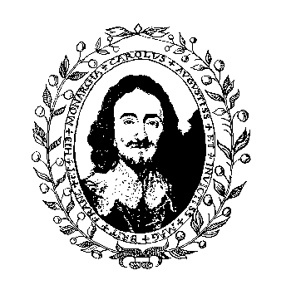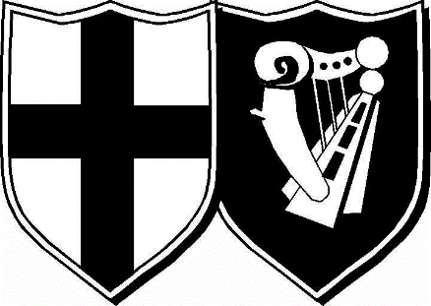

The English Civil War Society

The King’s Army The Roundhead Association

Press Information

54th ANNUAL MARCH IN COMMEMORATION OF CHARLES I,
EXECUTED ILLEGALLY on 30TH JANUARY 1649

On Sunday 25th January 2026 several hundred members of the King’s Army of the English Civil War Society will march in the footsteps of King Charles I in commemoration of his death at the hands of the Parliament in 1649. This will be the 54th time that the King’s Army has commemorated this event.

The soldiers of this modern recreation of the Royalist Army of the English Civil Wars are all volunteers and will be clothed and equipped in the same way as their forebears 375 years ago. Should the weather turn to snow, as it did then, some of them may follow the King’s example and wear two shirts so as not to be seen to shiver with the cold.

The march will commence on the Mall outside St James’ Palace at 11:20 am, proceed down the Mall and assemble on Horse Guards Parade where a religious drumhead service is held, a colour is trooped and blessed, the Oath of Loyalty is administered and awards and commissions are presented. The wreath, which ‘Remembers His Majesty’s Horrid Murder’, is then blessed and trooped around the whole army before being taken by the honour guard through Horse Guards Arch and across to the Banqueting House at around 12:30 pm and laid where the deed was carried out. The King’s Army official policy is never to refer to it as execution as this infers a legal act, which this was not.

Another wreath will already have been laid in advance at the base of the equestrian statue of Charles I at the top end of Whitehall in Trafalgar Square.

The King’s Army spends the summer months re-enacting historical events of the seventeenth century with The Roundhead Association. Our main events this year are: Hylton Castle, Sunderland 3&4 May, Chippenham 25&26 July and Newport Pagnell 28-30 August. The English Civil War Society also undertakes numerous educational activities and conducts historical research into the life and times of the seventeenth century.

A PRESS BRIEFING by the Press Officer takes place at 10:30 am at the memorial to Queen Mary by the junction of Marlborough Road and the Mall outside St James’ Palace.

www.ecws.org.uk
Further details available from Berry Healey 07957 661085

